(1MN) model

|  |  |  |
| --- | --- | --- |
|  |  | () |
|  |  |  |
|  |  | () |
|  |  |  |
|  |  | () |
|  |  |  |
|  |  | () |
|  |  |  |
|  |  | () |

Steady state:

|  |  |  |
| --- | --- | --- |
|  |  | () |

The Jacobian of Eqs. (1)-(4) is

|  |  |  |
| --- | --- | --- |
|  |  | () |

he eigenvalues of the Jacobian satisfy the characteristic equation:

|  |  |  |
| --- | --- | --- |
|  |  | () |

Eq. (8) can be expanded to



|  |  |  |
| --- | --- | --- |
|  |  |  |

|  |  |  |
| --- | --- | --- |
|  |  | () |

Take the derivative of Eq. (5) yields

|  |  |  |
| --- | --- | --- |
|  |  | () |

Use the same optimization procedure as SNF 0M8 with the constraint that Km>Kd, Ka>Kd

Use the initial parameter below to start the optimization search

[At alpha Vmax Km Ka] = [3 3 0.4 0.5 5];

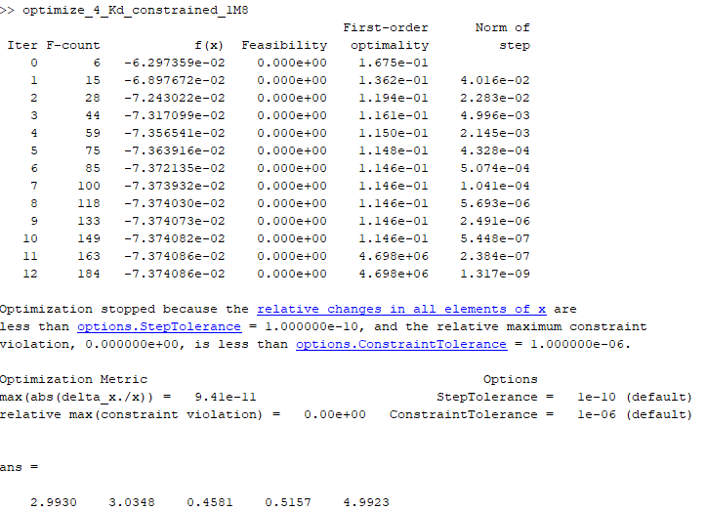

Kd = 0.07374

At = 2.9930, alpha = 3.0348, Vmax = 0.4581, Km = 0.5157, Ka = 4.9923

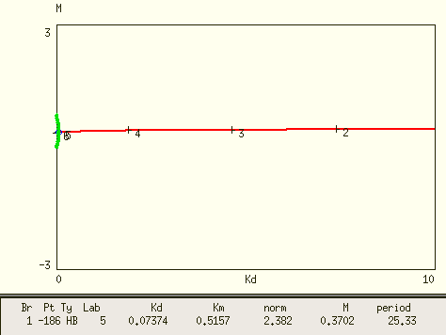

Xpp confirms it is a HB.

2D bifurcation curves

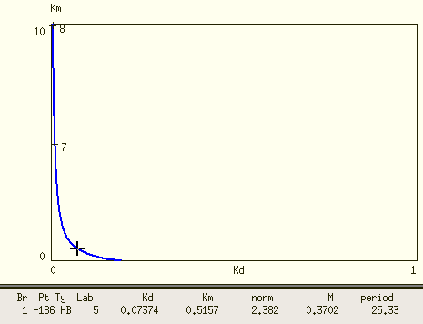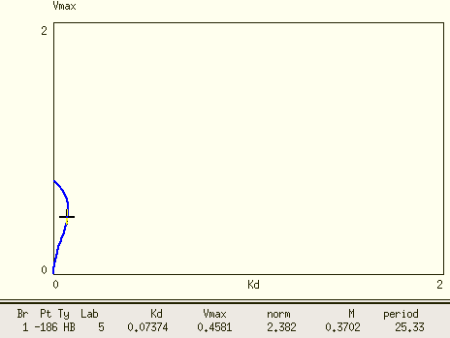

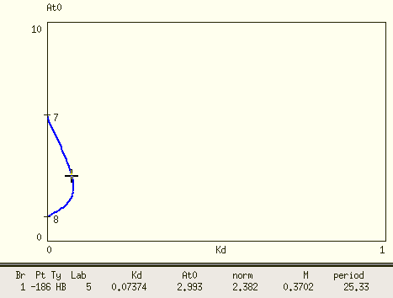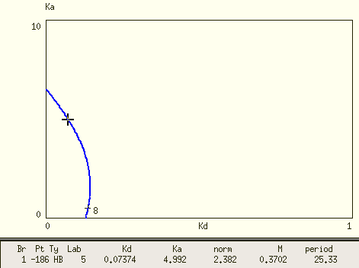

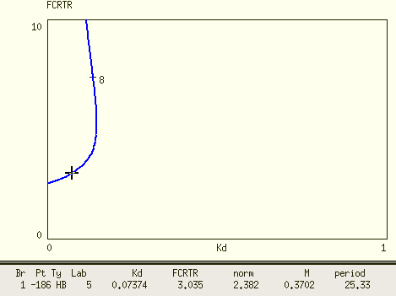

If chose Kd=0.04

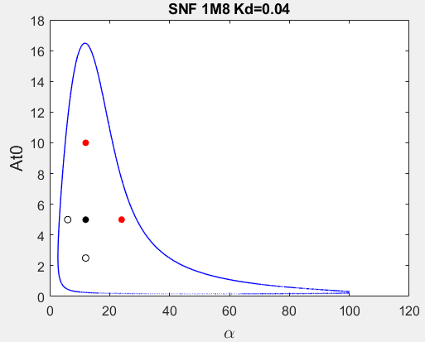

Pick alpha=12, At0=5 for homozygous diploid.

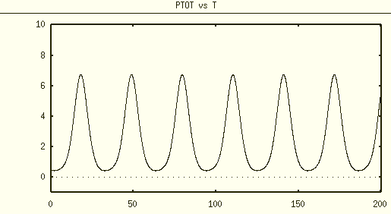

max(Ptot) = 7

P* = 100nM/max(Ptot)

Dimensional Kd~0.04*100/7 =0.57

The parameter returned by our optimization algorithm seems to be located in a very different parameter regime as compared from SNF 0M8. The dimensional Kd also seems too small. To determine a better parameter set for SNF 1M8 model, I use the same Kd, At0, alpha, Vmax, Km from SNF 0M8 parameter set while tuning Ka to have similar dimensional Kd.

Kd = 0.3

At = 6     alpha = 6    Vmax=1.3    Km=1 Ka=1

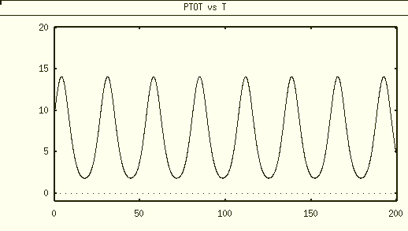

max Ptot~14

P* = 100nM/max(Ptot)

Dimensional Kd~0.3*100/14 =2.14, which is very similar to SNF 0M8.

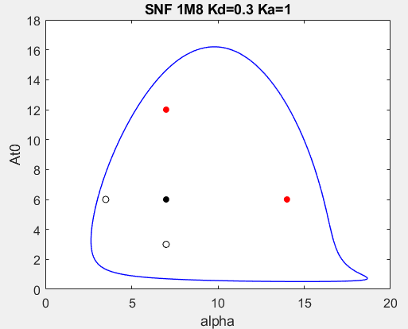

To make heterozygous diploid and tetraploid cells also located within oscillatory region, further tune alpha=7, At0=6

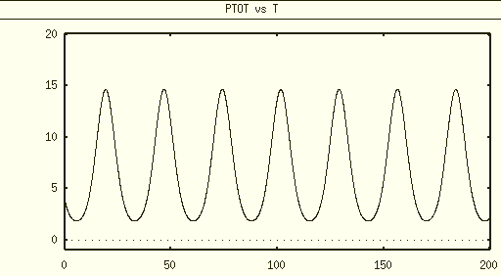

max Ptot~15

P* = 100nM/max(Ptot)

Dimensional Kd~0.3*100/15 =2, which is very similar to SNF 0M8.